Working on your teacher page(s) in Site Manager

Go to www.santoisd.net and click on the “Sign In” spot at the top right of the page.
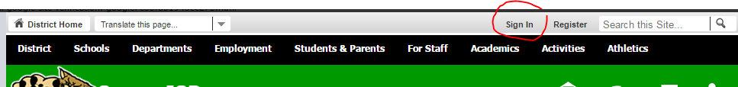

Type in your username (the first part of your email; ex: ggilbert). Your temporary password is 123456.
PLEASE change your password! Go to the same area that now says “My Account” and go to “Edit Account Settings”
to change your password.

Once that is completed, go back to the same area at the top right of the home page and choose “Site Manager”.
A window will pop-up with all of the sections you have access to listed on the left, if you have more than your teacher page.

Shown below is an example of what your teacher site will look like. Schoolwires has great help videos and articles in the “How do I…?” tab. There will be training on this in August!

